Undies Sunday
August 7, 2022
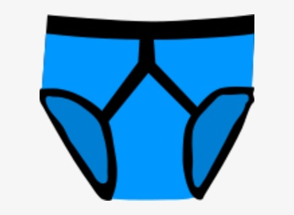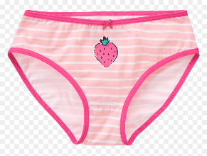
We are collecting new underwear for boys and girls at Centerville Elementary School. We need sizes 4T through Youth XL. We would like to give the underwear to the guidance counselors at the Centerville Teacher & Staff Luncheon on Tuesday, August 9th. If you are interested in supporting this Mission/Outreach project, please drop off new underwear in the box left inside the double doors to the new addition by Sunday, August 7th. Thank you!

