SHILOH UNITED METHODIST CHURCH
JULY 2023
Reach Out, Know, Embrace, Serve

1000 Spring Hill Road, Gilbert, South Carolina (803)892-5656

Welcome to Shiloh
Pastor John Kronz

Pastor Kronz is a native South Carolinian from a military family. Since 2019, he has served as the local pastor in a two-church charge in North, South Carolina. He received his BA in history from Francis Marion University and his Masters in Divinity from the Lutheran Southern Theological Seminary. John will be residing in the Cayce/West Columbia area with his dog and two cats. His heart was won over to Christ and the United Methodist Church as a child by members of his local congregation.

JULY BIRTHDAYS
7/3 Jordon Bennett 7/21 Mary Alice Bennett, William Kline,
7/5 Linda White Kelsey Richmond
7/7 Bennie Kline 7/22 Casey Sigler
7/8 Margaret Frick Ryan Young
7/10 Chris Lollis 7/23 Gary Spires
7/14 Patty Buckley 7/27 Shannon Mercer
7/16 Max Young 7/28 Donna Griffin, Jim Sanders
7/19 Janet Deep, Sarah Lollis 7/31 Brian Derr

JULY WEDDING ANNIVERSARIES
7/1 Lisa and Mike Daugherty
7/4 Teresa and Bobby Kovac
7/16 Britney and Blake Rosier
7/25 Nancy and Max Young
7/26 Luann and John Tetanich

PRAYER REQUESTS
The United Methodist Church, our country, the people of Ukraine, Becky Addy, Dick Addy, Jessie Bowman, Sydney Casting, Richard and Dee Dee Chewning, Kim Clark, Ken Colton & family, Andrea Crosby’s mother Margie Campbell, Paul Cruz, Candy Dawkins, Chris Dendy, Kenzer and Emily Green, Curtis Gillette, Jean & Ray Jadin, Matt James, Dot Keenan, Jeanne Kirk, John Lewis, Mary Lewis, Cheryl Long, Nicholas Manly, Jessica Mayo & Grayson, Susan McDaniel’s family, Susan McDaniel’s niece, Miriam McCoy, Willy Mendoza, Wayne Parrish, Ashley Price, Judy Price, Mike Pope, Kristie Riser, Richard Smith, Wilma Smith, Diana Tanner, Syrembia Taylor, Charles Thompson, Baby Grayson Tibbs, Lois and Ron Vanderstelt, Parker Wideman, teachers, students, administrators, parents, pastors, our leaders, and those fighting COVID-19.

FROM CHURCH COUNCIL

BBQ Butt Fundraiser –
The Shiloh BBQ Butt Fundraiser was a success. We will be applying over $1,200 to the building fund to pay down our mortgage. Thank you to all of you that sold, purchased, advertised and/or distributed the butts.

Sunday School – Sunday School will be discontinued until September.

Vacation Bible School – Thank you to all of the volunteers that supported this year’s vacation bible school. It was a great success with 22 children participating. Thank you to Malachi for the leadership and guidance.

Centerville Elementary Luncheon – Shiloh will be hosting a luncheon for the faculty and staff of Centerville Elementary School on August 3, 2023. We need help! There are a couple of opportunities for you to help make this a success:

We will need help preparing/setting up for the luncheon on the first and/or second of August.

Each person attending the luncheon will receive a bag with items from local businesses and individuals. Also, we will draw for door prizes. We need help contacting local businesses for donations. There will be 110 attending, however, if a business cannot donate 110, we can use whatever they can give. Gift baskets and items for gift baskets are needed as well.

We will need help setting up the luncheon, cleaning up and serving on the day of the event.

Welcome new preparatory roll members – Sunday, June 18, 2023 was not only Pastor Angie’s last Sunday in the pulpit at Shiloh but she was able to baptize five children and bring them into the Shiloh family as preparatory members. Baptized were Bradlee Ryan, Kodie Ryan, Baylen Mayo, Bennett Tibbs and Greyson Tibbs. In addition, there were two baptism renewals of children already on the preparatory roll: Mollie Kate Smith and Roland Smith. What a great day for Shiloh and a wonderful send off for Pastor Angie.
Whoever receives one such child in my name receives me, and whoever receives me, receives not me but him who sent me.” (Mark 9:37)
MARY BAKER

MISSION/OUTREACH

Epworth Children's Home - Thanks to all who contributed items or money for our Epworth Children's Home mission project. As a result of your generosity, we were able to fully equip two "welcome" baskets for newly arriving residents at Epworth providing all bedding, bath supplies, personal care items, clothing and more. We were also able to purchase items from Epworth's wish list to provide paper products and cleaning supplies for Epworth.
Centerville Elementary School - Shiloh will once again be hosting a luncheon for Centerville Faculty & Staff on August 3rd. Anyone interested in assisting in planning and hosting this luncheon please contact Ann Milligan (803-331-6252) or Clyde Sanders (803-608-4855). Centerville has some back-to-school needs. If you are interested in supporting this school ministry, please drop off items in one of the two Centerville bins on the shelves just inside the double glass doors between the sanctuary & fellowship hall. Here is their wish list:
Boys/Girls underwear (sizes 4-5, 6-8, 10-12, 14-16)
Girls leggings (sizes 4-5, 6-8, 10-12, 14-16)
Boys/Girl shorts (sizes 4-5, 6-8, 10-12, 14-16)
Lunch bags
Stress balls
Insulated water cups
We will do an Undie Sunday drive again this year on Sunday, July 30th. Please see the attached flyer.
Gilbert Middle School - Children return to school again on August 9th. We would like to drop off a fresh supply of healthy snacks at GMS on Monday, August 7th. If you are interested in supporting this outreach ministry, please drop off items in the GMS bin on the shelf inside the doors of the fellowship hall. Here is a list of requested individually packaged items:
Granola Bars
Protein Bars
Energy Bars
Cheese Crackers
Peanut Butter Crackers
Goldfish Crackers
Trail Mix
Fruit Cups
Thank you to all of our Shiloh members for your continued support of Mission/Outreach activities. You are a blessing to our community!

ANN MILLIGAN

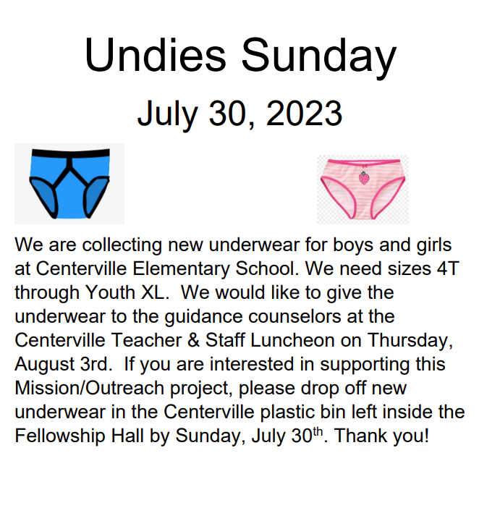

What’s Going on at Shiloh?

7/1 Pick up your order of Boston Butts between 9 and 11am.
7/1 Dinner at the home of Mike and Lisa Daugherty at 6:30 pm
to welcome Pastor John Kronz. Stay and watch the fireworks at 9:30.
7/2 First day in Shiloh pulpit for Pastor John.
7/4 Independence Day.
7/23 Kalia and Mia leave for Asbury Hills

Please join us for Worship Service each
Sunday at 10:00 AM.

